**PRACTICAL 9:Mongodb**

**1.AIM:**

To understand how to use MongoDB

**2.WRITEUP**:

What is MongoDB?

MongoDB is an open-source document database and leading NoSQL database. MongoDB is written in C++.

**1.The use Command:**

MongoDB use DATABASE_NAME is used to create database. The command will create a new database if it doesn't exist, otherwise it will return the existing database.

Basic syntax of use command is as follows-

Use databasename;

**2.The createCollection() Method**

MongoDB db.createCollection(name, options) is used to create collection.

Basic syntax of createCollection() command is as follows −

db.createCollection(name, options);

**3.The insert() Method**

To insert data into MongoDB collection, you need to use MongoDB's insert() or save() method.

Syntax

The basic syntax of insert() command is as follows −

db.COLLECTION_NAME.insert(document);

**4.The find() Method**

MongoDB's find() method, explained in MongoDB Query Document accepts second optional parameter that is list of fields that you want to retrieve. In MongoDB, when you execute find() method, then it displays all fields of a document. To limit this, you need to set a list of fields with value 1 or 0. 1 is used to show the field while 0 is used to hide the fields.

**3.PRACTICALS**:

Create database

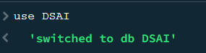

Create collection

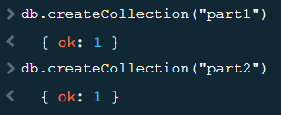

Show collections

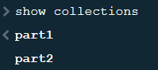

Insert data into collection

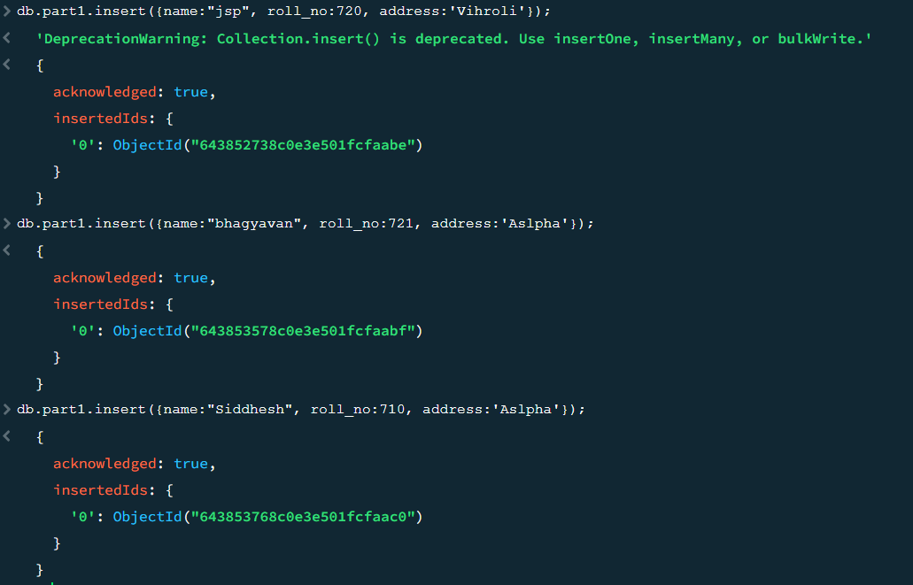

Insert data using insertMany() function

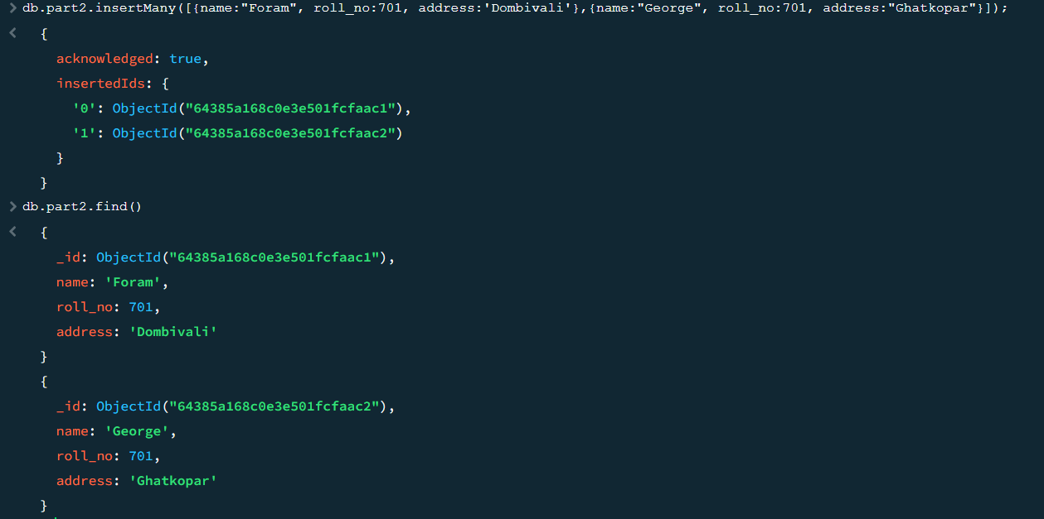

Find the inserted data

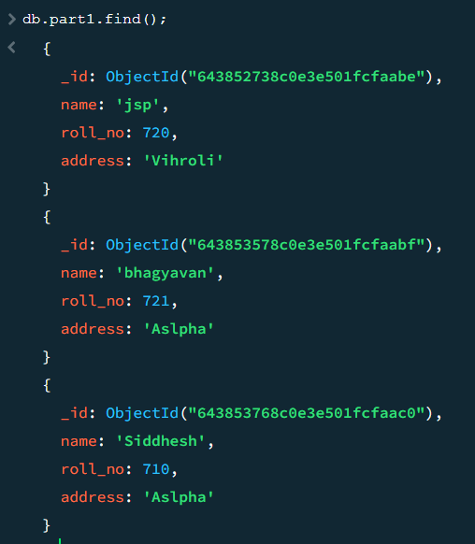

Find first inserted data from the collection using findOne function

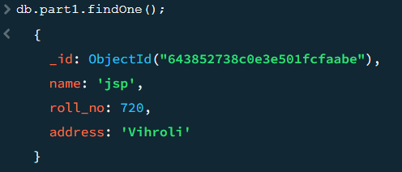

Find data which has roll_no less then 720

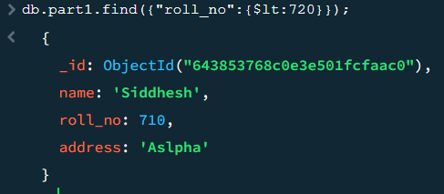

Update Name to Jayesh

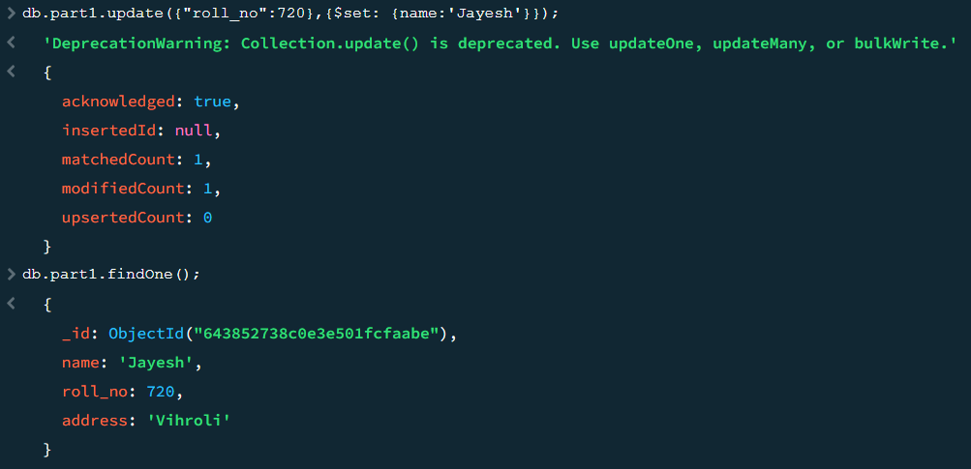

Drop collection

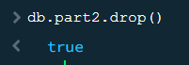

Drop datadatabase

